Mission Horse Club

Spring Hanging Basket Sale 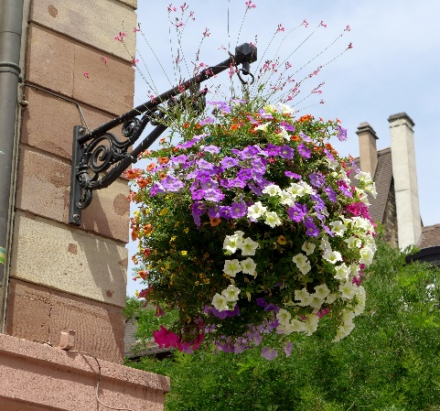 $22.00 Each 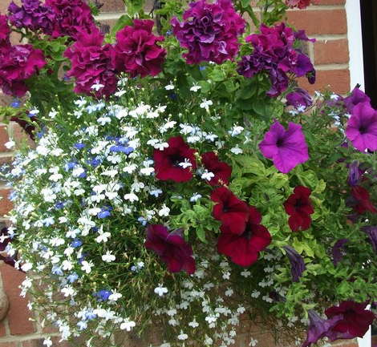
Pick up Saturday May 9th
E-transfer to martyeyes@hotmail.com
#Full # Partial Baskets Total Payment
Name Phone Sun Sun Total Paid Method

- ___________________________________________________________________________
- ___________________________________________________________________________
- ___________________________________________________________________________
- ___________________________________________________________________________
- ___________________________________________________________________________
- ___________________________________________________________________________
- ___________________________________________________________________________

